**Curriculum Vitae**

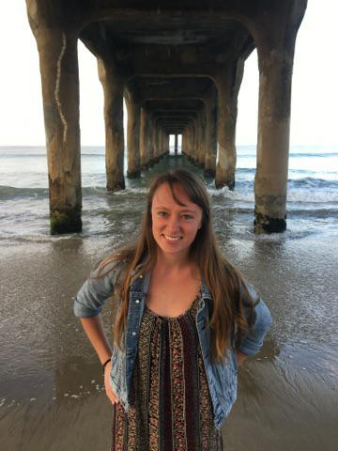

Clémence Bossé-Audet

Speciality : Artistic cycling

Other discipline : Juggling/passing, clown, gymnastic

Date of Birth: April 12 1996

Email : [clemence.bosse-audet@hotmail.com](mailto:clemence.bosse-audet@hotmail.com)

Website : [www.clemencebosse.com](http://www.clemencebosse.com)

Phone number : 418-931-3842

**Professional Experience**

* **Hone Production,** TV Commercial for SunnyD Light, *Miami Florida*, may 4th to may 7th 2018
* **FISE**, Vendée Freestyle session show, *La-Roche-sur-Yon*, 29 mars au 1 avril 2018



* Company **All Wheel Sport**, *Acroflyte*, California, June 2016 to August 2016

***Télévision experience :***

* TV Commercial as a bike performer for SunnyD Light 2018

***Stage experience :***

* FISE, Vendée Freestyle session show, March 29th to April 1st 2018
* Company **All Wheel Sport**, summer 2016-2017
* Final year show of École de Cirque de Québec 2014-2015-2016
* Other stage experience in the leisure program of École de Cirque de Québec 2003-2016

***Animation :***

* Circus workshop for kids with the company FlipToP 2018
* Circus workshop for kids with Marie-Stella 2018
* *Bicycle Film Festival* of Quebec city (2016)
* Les **Foutoukours**, *Bicycle Film Festival* of Québec (2014 and 2015)
* Quebec city circus School
* Several benefit night for specific organisation 2012-2015
* Demonstration for the Vélothon of Université Laval 2013

***Competition :***

* Bicycle World Championship, Germany/Stuttgart, 2016
* Bicycle World Championship, Czech Republic/Brno, 2014

***Formation :***

* 3 years of professional formation at the Circus School of Quebec city, graduated in 2016
* Clown formation and workshop with Geneviève Kerouac, René Bazinet, Michel Dallaire 2013-2016
* Bicycle workshop with the german coach of team Canada Kathrin Igel 2012-2017
* Workshop of street animation with les Foutoukours 2015
* Hip hop workshop with Sarah-Louise Latour and swing workshop with Céline Cartelli 2015
* Workshop of video support with Ludovic Fouquet painter and artistic director 2014

***Other :***

* Training at École de Cirque de Québec since 2012 in the leisure program
* Member of an improvisation league in 2009-2012
* Participation in a hiphop leisure summer camp